Declaration

I hereby declare that the work, which is being presented in the project entitled **Facial Emotion Analysis System** partial fulfillment of the requirement for the award of the degree of **Bachelor of Technology**, submitted in the Department of Computer Science & Engineering at **AITR, Indore** is an authentic record of my own work carried under the supervision of **Asst Prof. Nidhi Nigam**. I have not submitted the matter embodied in this report for the award of any other degree.

**Guided By Submitted By**

Asst. Prof. Nidhi Nigam Sameer Ansari (0827CS171187)

Shubham Chandrol (0827CS171207)

Tanish Verma (0827CS171223)

AITR Indore

Department of Computer Science & Engineering



Certificate

The project work entitled **FACIAL EMOTION ANALYSIS SYSTEM** submitted by **SAMEER ANSARI, SHUBHAM, CHANDROL AND TANISH VERMA** is approved as partial fulfillment for the award of the degree of Bachelor of Technology in Computer Science & Engineering by Rajiv Gandhi Proudyogiki Vishwavidyalaya, Bhopal (M.P.).

**Internal Examiner External Examiner**

Name:………………. Name: ……………..

Date: …./…/……….. Date: …./…/………..

Acknowledgment

With boundless love and appreciation, we would like to extend our heartfelt gratitude and appreciation to the people who helped us to bring this work in reality. We would like to have some space of acknowledgment for them.

Foremost, we would like to express our sincere gratitude to our supervisor, **Prof. Asst Nidhi Nigam** whose expertise, consistent guidance, ample time spent and consistent advice that helped us to bring this study into success.

To the project in-charge **Prof.Asst Anil K Patidar and Prof.Asst Avinash S Bundela** for their constructive comments, suggestions, and critiquing even in hardship.

To the honorable **Dr. Sanjay Bansal**, Head, Department of Computer Science & Engineering for his favorable responses regarding the study and providing the necessary facility.

Finally, we would like to pay our thanks to faculty members and staff of the Department of Computer Science & Engineering for their timely help and support.

We also like to pay thanks to our **parents** for their eternal love, support, and prayers. Without them, it is not possible.

Sameer Ansari (0827CS171187)

Shubham Chandrol (0827CS171207)

Tanish Verma (0827CS171223)

ABSTRACT

These Human facial expressions convey a lot of information visually rather than articulately. Facial expression recognition plays a crucial role in the area of human-machine interaction. Automatic facial expression recognition system has many applications including, but not limited to, human behavior understanding, detection of mental disorders, and synthetic human expressions. Recognition of facial expression by computer with high recognition rate is still a

challenging task.

Two popular methods utilized mostly in the literature for the

automatic FER systems are based on geometry and appearance.

Facial Expression Recognition usually performed in four-stages

consisting of pre-processing, face detection, feature extraction, and expression classification.

In this project we applied various deep learning methods

(convolutional neural networks) to identify the key seven human

emotions: anger, disgust, fear, happiness, sadness, surprise and

neutrality.

Table of Content

Pg. No.

**Declaration…………………………………………………………………………..ii**

**Project Approval Form……………………………………………………………..iii**

**Certificate…………………………………………………………………………....iv**

**Acknowledgement…………………………………………………………………...v**

**Abstract……………………………………………………………………………...vi**

1. **Introduction** 
   1. **Rationale**
   2. **Problem Definition and Proposed Solution**
   3. **Objective and Scope**
   4. **Report Organization**
2. **Literature Survey** 
   1. **Background**
   2. **Related Work**
3. **System Requirement Specification**
   1. **Hardware Requirements**
   2. **Software Requirements**
4. **System Analysis & Design**
   1. **System Analysis**
      1. **Requirement Analysis**
      2. **Feasibility Analysis**
   2. **System Design**
      1. **Use Case Diagram**
      2. **Use Case Specification**
      3. **Activity Diagram**
      4. **Sequence Diagram**
      5. **Subsystem Class Design ( Generic)**
      6. **Subsystem Class Design ( Implementation Specific )**
      7. **Data Model (ER Diagram)**
      8. **Attach Data flow Diagram**
5. **Project Implementation & Output Screens**

**Screenshots of your Project**

**Important Coding**

1. **Testing**
   1. **Testing Strategy Adopted**
   2. **System Testing**
   3. **Unit Testing**
   4. **Test Cases**
2. **Results & Outputs. (Only for Research Based Project.)**
3. **Functional & Non Functional Requirement**
   1. **Performance Requirement**
   2. **Reliability**
   3. **Scalability**
   4. **Security**
   5. **Testability**

1. **Conclusion** 
   1. **Conclusion**
   2. **Future Enhancement**

**Appendix A:**

**Glossary**

**User Manual**

**Appendix B:**

**ReferencesAbbreviations**

Symbol Word

* OCR Optical Character Recognition
* ICR Intelligent Character Recognition
* SOM Self-Organizing Map

**INTRODUCTION**

**1.Introduction**

**“2018 is the year when machines learn to grasp human emotions”** --**Andrew Moore, the dean of computer science at Carnegie Mellon.**

With the advent of modern technology our desires went high and it binds no bounds. In the present era a huge research work is going on in the field of digital image and image

processing. The way of progression has been exponential and it is ever increasing. Image

Processing is a vast area of research in present day world and its applications are very

widespread.

Image processing is the field of signal processing where both the input and output signals are images. One of the most important application of Image processing is Facial expression recognition. Our emotion is revealed by the expressions in our face. Facial Expressions plays an important role in interpersonal communication. Facial expression is a non verbal scientific gesture which gets expressed in our face as per our emotions. Automatic recognition of facial expression plays an important role in artificial intelligence and robotics and thus it is a need of the generation. Some application related to this include Personal identification and Access control, Videophone and Teleconferencing, Forensic application, Human-Computer Interaction, Automated Surveillance, Cosmetology and so on.

The objective of this project is to develop Automatic Facial Expression Recognition System which can take human facial images containing some expression as input and recognize and classify it into seven different expression class such as :

|  |
| --- |
|  |

**I. Neutral II. Angry**

**III. Disgust**

**IV. Fear V. Happy**

**VI. Sadness**

**VII. Surprise**

Several Projects have already been done in this fields and our goal will not only be to developan Automatic Facial Expression Recognition System but also improving the accuracy of this system compared to the other available systems.

## 1.1 Rationale

Significant debate has risen in past regarding the emotions portrayed in the world

famous masterpiece of Mona Lisa. British Weekly „New Scientist‟ has stated that she

is in fact a blend of many different emotions, 83%happy, 9% disgusted, 6% fearful,

2% angry.



**Fig 1**

We have also been motivated observing the benefits of physically handicapped

people like deaf and dumb. But if any normal human being or an automated system

can understand their needs by observing their facial expression then it becomes a lot

easier for them to make the fellow human or automated system understand their

needs.

 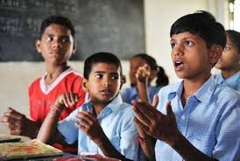

**Fig 2 Fig 3**

## 1.2 Problem Definition & Proposed Solution

Human facial expressions can be easily classified into 7 basic emotions: happy, sad,

surprise, fear, anger, disgust, and neutral. Our facial emotions are expressed through

activation of specific sets of facial muscles. These sometimes subtle, yet complex,

signals in an expression often contain an abundant amount of information about our

state of mind. Through facial emotion recognition, we are able to measure the effects

that content and services have on the audience/users through an easy and low-cost

procedure. For example, retailers may use these metrics to evaluate customer interest. Healthcare providers can provide better service by using additional information about patients' emotional state during treatment. Entertainment producers can monitor audience engagement in events to consistently create desired content.

Humans are well-trained in reading the emotions of others, in fact, at just 14 months

old, babies can already tell the difference between happy and sad. **But can computers do a better job than us in accessing emotional states?** To answer thequestion, We designed a deep learning neural network that gives machines the abilityto make inferences about our emotional states. In other words, we give them eyes tosee what we can see.

***PROBLEM FORMULATION OF OUR PROJECT***



**Facial expression recognition is a process performed by humans or computers, which consists of:**

**1.** Locating faces in the scene (e.g., in an image; this step is also referred to as

Face detection),

**2.** Extracting facial features from the detected face region (e.g., detecting the shape

of facial components or describing the texture of the skin in a facial area; this step

is referred to asfacial feature extraction),

**3.** Analyzing the motion of facial features and/or the changes in the appearance of

Facial features and classifying this information into some facial-expression interpretative categories such as facial muscle activations like smile or frown,

emotion (affect) categories like happiness or anger, attitude categories like

(dis) liking or ambivalence, etc.(this step is also referred to as facial expression

interpretation).

Several Projects have already been done in this fields and our goal will not only

be to develop a Automatic Facial Expression Recognition System but also

improving the accuracy of this system compared to the other available systems.

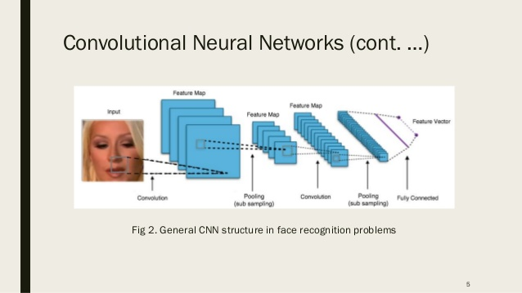

**FIG 4**

## 1.3 Objective and Scope

The main objective of this project is to build an automated system by using Convolutional Neural Network and Deep learning capable of accurately recognising the human emotions based on the live images or pre-captured images.There are many systems similar to this, but our objective is to create a system with better accuracy and improved results. This project can be used in many industries and Companies as through facial expression recognition the Company/Industry professionals can gauge the customers reaction/satisfaction with their service or product. The **intended users** for this project are –

* IT professionals.
* HealthCare Organisations.
* Gaming Industries.
* Automobile Sector.
* Banking Services.

**The scopes of this project ar**e **–**

* **Analysis of human face –**

The system will first take the input image and then it will analyse the image and target on the faces present in the image.

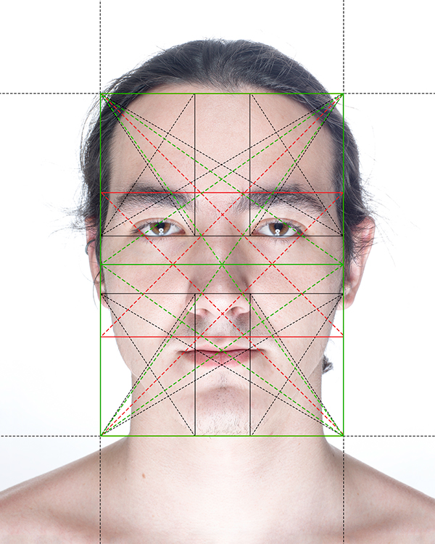

* **Evaluating the emotion displayed on the face**-

After analysis the image, the system will extract the facial features from the image and try to predict the correct expression.

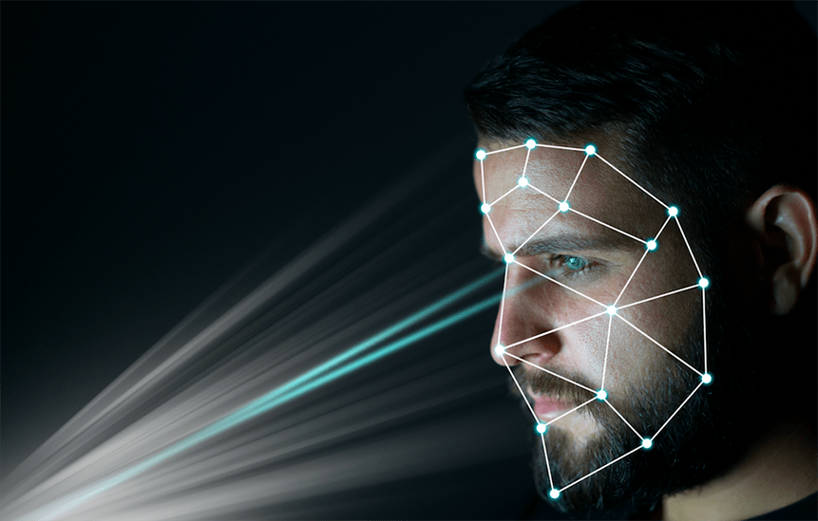

* **Predicting the correct expression displayed as per the given input-**

Now the system will generate the result in the form of text, the text will tell us the expression displayed on the face in the image

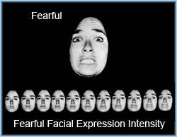

### Usefulness

This is a research based project. In future it could be used in multiple fields like-

1.App and Product Development.

2.Gaming Industry.

3.Improved Learning Practices.

4.Improved Web Developments.

Reliability based on this system defines the evaluation result of the system, correct identification of the facial expressions and maximum evaluation rate of the facial expression recognition of any input images.

## Planning-

## Risk Management

Risk management means risk containment and mitigation. First, you’ve got to identify and plan. Then be ready to act when a risk arises, drawing upon the experience and knowledge of the entire team to minimize the impact to the project.

* Identify risks and their triggers.
* Classify and prioritize all risks.
* Craft a plan that links each risk to a mitigation.
* Monitor for risk triggers during the project.
* Implement the mitigating action if any risk materializes.
* Communicate risk status throughout the project.

### Project Risk

Some of the major risks that may happen during the life cycle of our project:

- An extra line of codes or redundant algorithm may cause wastage of memory.

- If the customer provides irrelevant information then it may generate some unknown risk.

- If a customer asks for change or gives some unexpected modification in later stages of development then it is difficult to alter the entire system design in accordance with that change.

- Lack of training on tools and inexperience may cause difficulty in completing project modules.

**Planning**-

The steps we followed while developing this project are-:

1. Analysis of the problem statement.

2. Gathering of the requirement specification

3. Analysation of the feasibility of the project.

4. Development of a general layout.

5. Going by the journals regarding the previous related works on this field.

6. Choosing the method for developing the algorithm.

7. Analyzing the various pros and cons.

8. Starting the development of the project

9. Installation of software like ANACONDA.

10. Developing an algorithm.

11. Analysation of algorithm by guide.

12. Coding as per the developed algorithm in PYTHON.

We developed this project as per the iterative waterfall model with feedbacks at multiple stages:

## Process Model Adopted

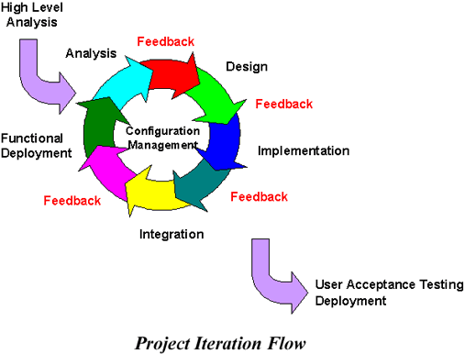

Figure 2.4 Process mode

**User Roles and Responsibilities**

The user has complete ownership of the application and responsible for any misuse of the application.

Responsibilities:

- Start and stop resources.

- Use the system operations controls.

## Requirements

### Functional Requirements

The functional requirements for a system describe what the system should do. Those requirements depend on the type of software being developed, the expected users of the software. These are statement of services the system should provide, how the system should react to particular inputs and how the system should behave in particular situation.

So our system will first process the input and remove all the noise and then will extract the features from the face then the hidden convolutional layers will work on it and will provide the output accordingly.

### Non-functional Requirements

* Performance: It should identify the facial expressions with the accuracy of 74%.
* Availability: This system will retrieve only the human face regions only if the image face in it.
* Flexibility: It provides the users to load the image easily.
* Learnability: The software is very easy to use and reduces the learning work.
* Reliability: This software will work reliably for low-resolution images and not for graphical images.
* Maintainability: The software requires very less maintenance.

## Tools Required

**Resources required for development**

Hardware configurations:

- CPU Intel Core i3-4005U

- MONITOR RESOLUTION - 800X600 minimum

- RAM - 4.00 GB

- HARD DISK – 100 GB

Software configurations:

- Window 7 or above

- Java Compiler 8

- Net Beans IDE 8.1

**Resources required for system application**

Hardware configurations**:**

- CPU Intel Core 2 Duo

- MONITOR RESOLUTION - 800X600 minimum

- RAM - 2.00 GB

- HARD DISK - 128GB

Software Requirements:

- Window 7 or above

## Designing-

## Use Case Diagram

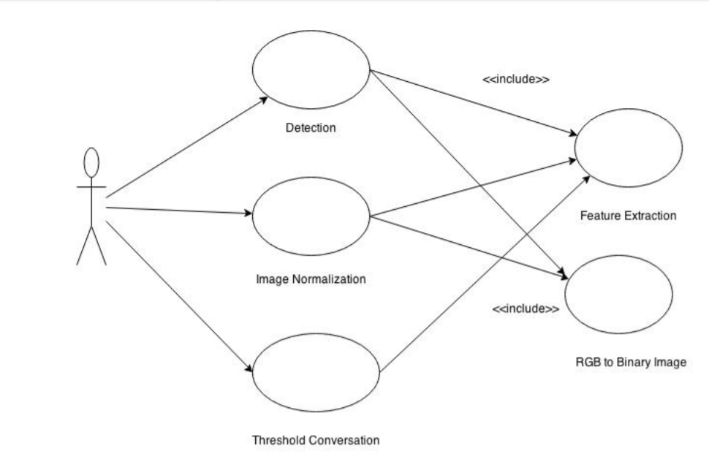

Figure 3.3 Use case diagram

### Use Case Description

* **Draw Character**

**Use Case:** Canvas

**Actor:** User

**Description:** User will be able to give input via webcam or with some tweaks can even use pre-loaded pictures .

**Precondition:** N.A.

**Post condition:** Ready to recognize and train.

**Basic Flow:**

**Subject Area:** Institution

**Actor:** Student

**Trigger:** As soon as the face is seen on the screen.

**Alternative Flow:** N.A.

* **Training Character**

**Use Case:** Train

**Actor:** User

**Description:** With the help of this use case the characters will be trained.

**Precondition:** Lighting should be sufficient.

**Post condition:** Ready to recognize.

**Basic Flow:**

**Subject Area:** Institution

**Actor:** Student

**Trigger:** As soon as the canvas records the pattern then, it will start observing the pattern.

**Alternative Flow:** Maybe the pattern is already recorded then it will not train that pattern.

* **Recognizing Character**

**Use Case:** Recognize

**Actor:** User

**Description:** With the help of this use case the expressions will be recognized.

**Precondition:** Only trained expressions would be displayed.

**Post condition:** N.A.

**Basic Flow:**

**Subject Area:** Institution

**Actor:** Student

**Trigger:** As soon as the face is seen on the screen.

**Alternative Flow:** N.A

## Technical Architecture

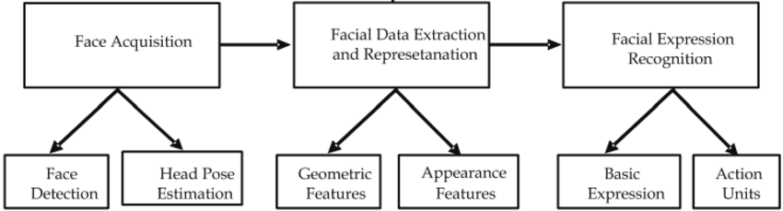

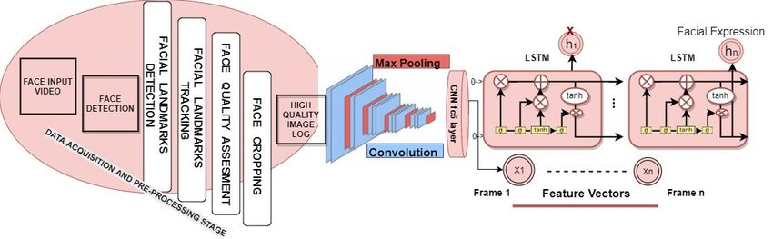

## Sequence Diagrams

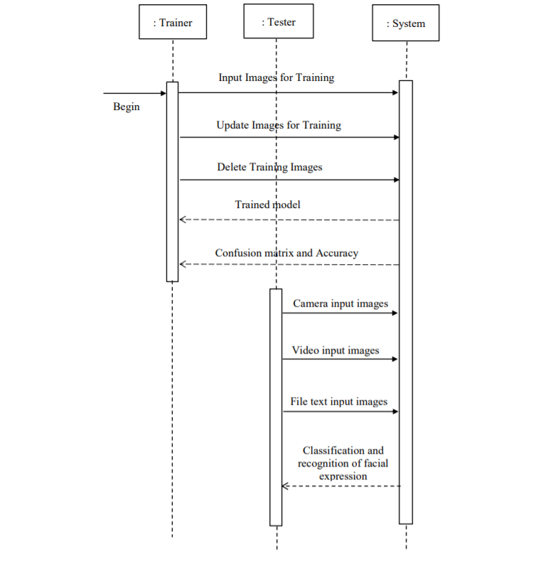

## Data Flow Diagrams

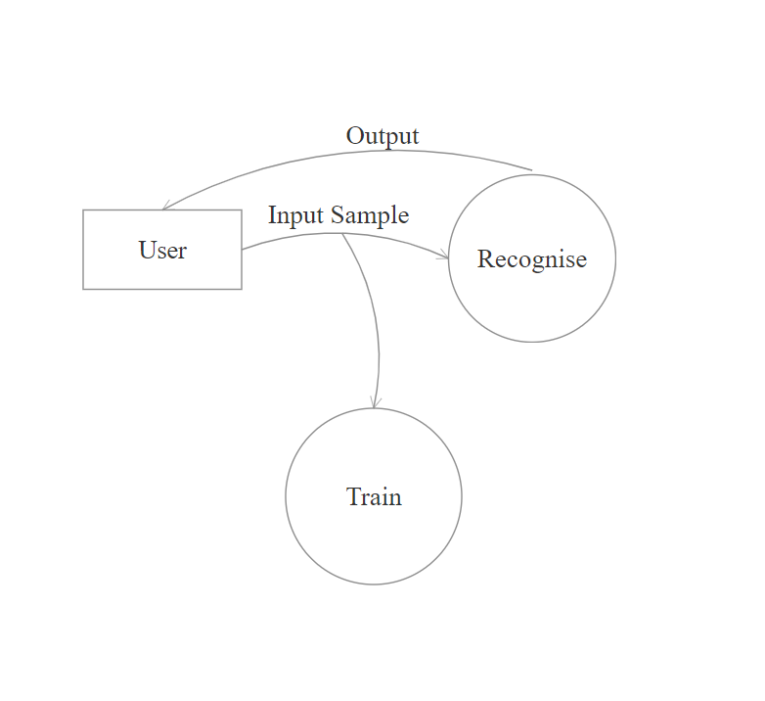

Figure 4.4.2 Level 0 DFD

**System Diagram**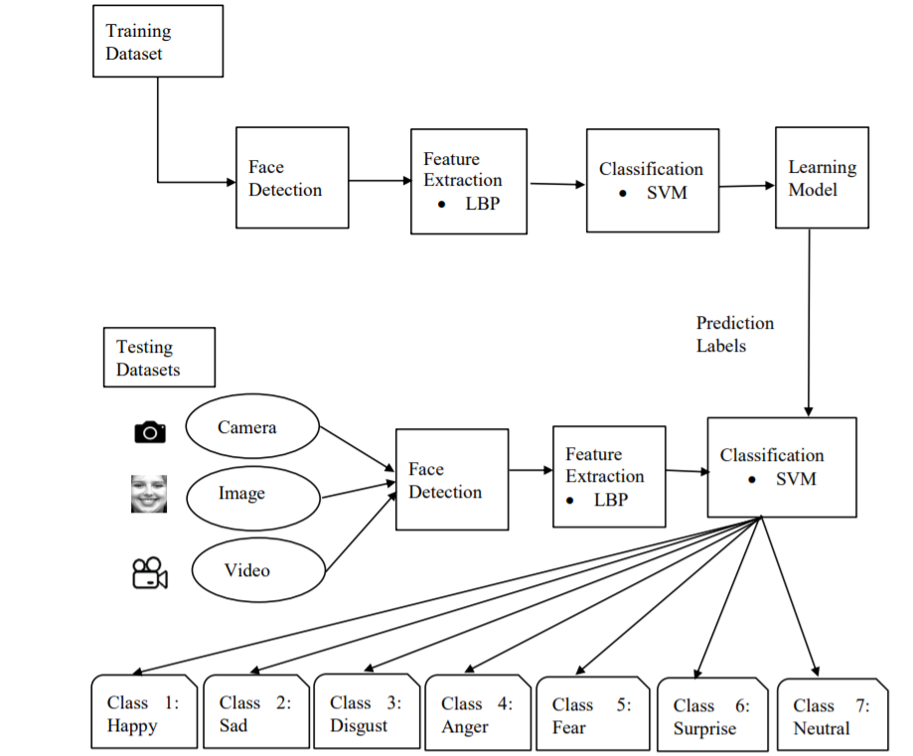

**Methodology-**

**Algorithm**

Step 1 :Collection of a data set of images. (In this case we are using FER2013 database of

35887 pre-cropped, 48-by-48-pixel grayscale images of faces each labeled with one of

the 7 emotion classes: anger, disgust, fear, happiness, sadness, surprise, and neutral.

Step 2 :Pre-processing of images.

Step 3 :Detection of a face from each image.

Step 4 :The cropped face is converted into grayscale images.

Step 5 : The pipeline ensures every image can be fed into the input layer as a (1, 48, 48)

numpy array.

Step 5 :The numpy array gets passed into the Convolution2D layer.

Step 6 :Convolution generates feature maps.

Step 7 :Pooling method called MaxPooling2D that uses (2, 2) windows across the feature

map only keeping the maximum pixel value.

Step 8 :During training, Neural network Forward propagation and Backward propagation

performed on the pixel values.

Step 9 :The Softmax function presents itself as a probability for each emotion class.

The model is able to show the detail probability composition of the emotions in the face.

**Proposed Algorithm** –

Before talking about Stochastic Gradient Descent (SGD), let’s first understand what is Gradient Descent? Gradient Descent is a very popular optimization technique in Machine Learning and Deep Learning and it can be used with most, if not all, of the learning algorithms. A gradient is basically the slope of a function; the degree of change of a parameter with the amount of change in another parameter. Mathematically, it can be described as the partial derivatives of a set of parameters with respect to its inputs. The more the gradient, the steeper the slope. Gradient Descent is a convex function.  
Gradient Descent can be described as an iterative method which is used to find the values of the parameters of a function that minimizes the cost function as much as possible. The parameters are initially defined a particular value and from that, Gradient Descent is run in an iterative fashion to find the optimal values of the parameters, using calculus, to find the minimum possible value of the given cost function.

Typically, there are three types of Gradient Descent:

Batch Gradient Descent

Stochastic Gradient Descent

Mini-batch Gradient Descent

In our Project we have used Stochastic Gradient Descent.

Stochastic Gradient Descent (SGD):

The word ‘*stochastic*‘ means a system or a process that is linked with a random probability. Hence, in Stochastic Gradient Descent, a few samples are selected randomly instead of the whole data set for each iteration. In Gradient Descent, there is a term called “batch” which denotes the total number of samples from a dataset that is used for calculating the gradient for each iteration. In typical Gradient Descent optimization, like Batch Gradient Descent, the batch is taken to be the whole dataset. Although, using the whole dataset is really useful for getting to the minima in a less noisy or less random manner, but the problem arises when our datasets get really huge.  
Suppose, you have a million samples in your dataset, so if you use a typical Gradient Descent optimization technique, you will have to use all of the one million samples for completing one iteration while performing the Gradient Descent, and it has to be done for every iteration until the minima is reached. Hence, it becomes computationally very expensive to perform.

This problem is solved by Stochastic Gradient Descent. In SGD, it uses only a single sample, i.e., a batch size of one, to perform each iteration. The sample is randomly shuffled and selected for performing the iteration.

SGD algorithm:

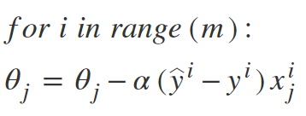

So, in SGD, we find out the gradient of the cost function of a single example at each iteration instead of the sum of the gradient of the cost function of all the examples.

In SGD, since only one sample from the dataset is chosen at random for each iteration, the path taken by the algorithm to reach the minima is usually noisier than your typical Gradient Descent algorithm. But that doesn’t matter all that much because the path taken by the algorithm does not matter, as long as we reach the minima and with significantly shorter training time.

Path taken by batch Gradient Descent-

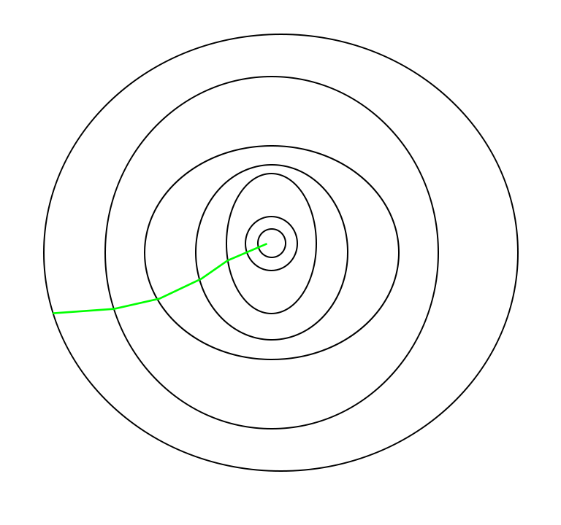

Path taken by Stochastic Gradient Descent –

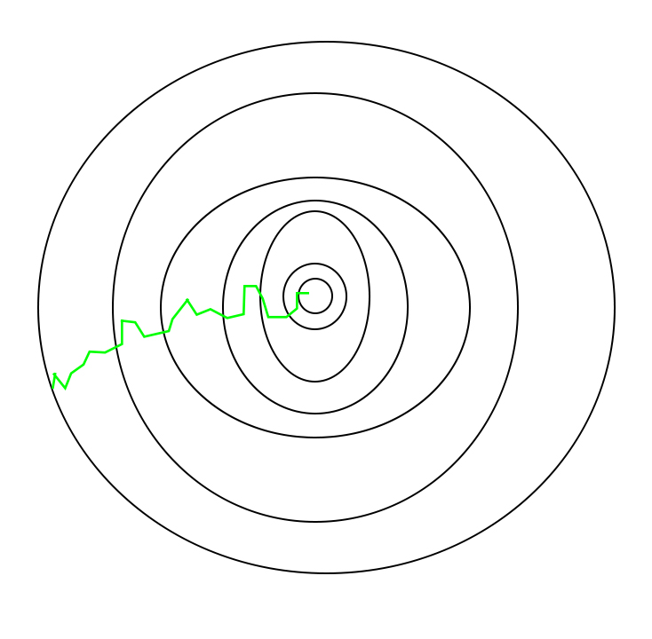

One thing to be noted is that, as SGD is generally noisier than typical Gradient Descent, it usually took a higher number of iterations to reach the minima, because of its randomness in its descent. Even though it requires a higher number of iterations to reach the minima than typical Gradient Descent, it is still computationally much less expensive than typical Gradient Descent. Hence, in most scenarios, SGD is preferred over Batch Gradient Descent for optimizing a learning algorithm.

**CODE SCREENSHOTS-**

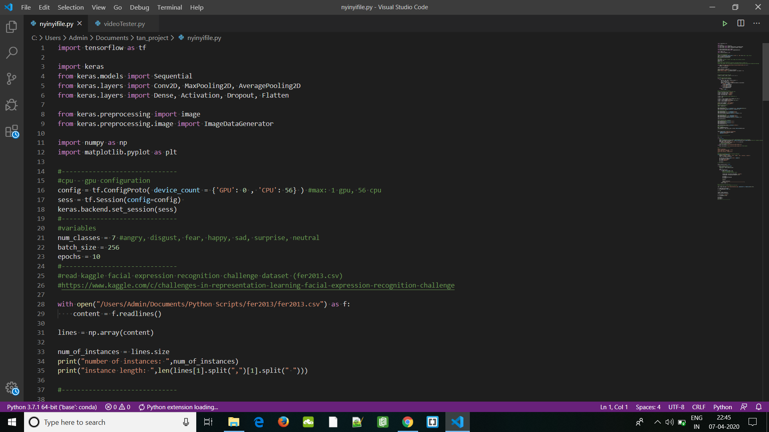

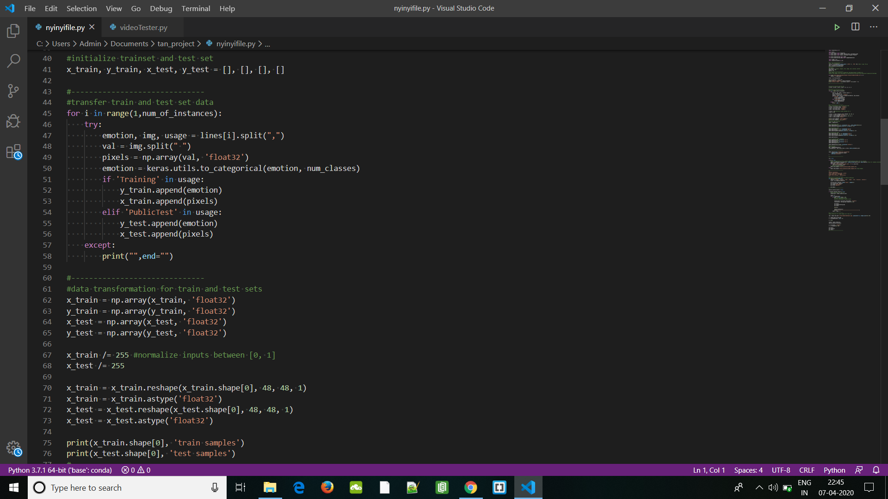

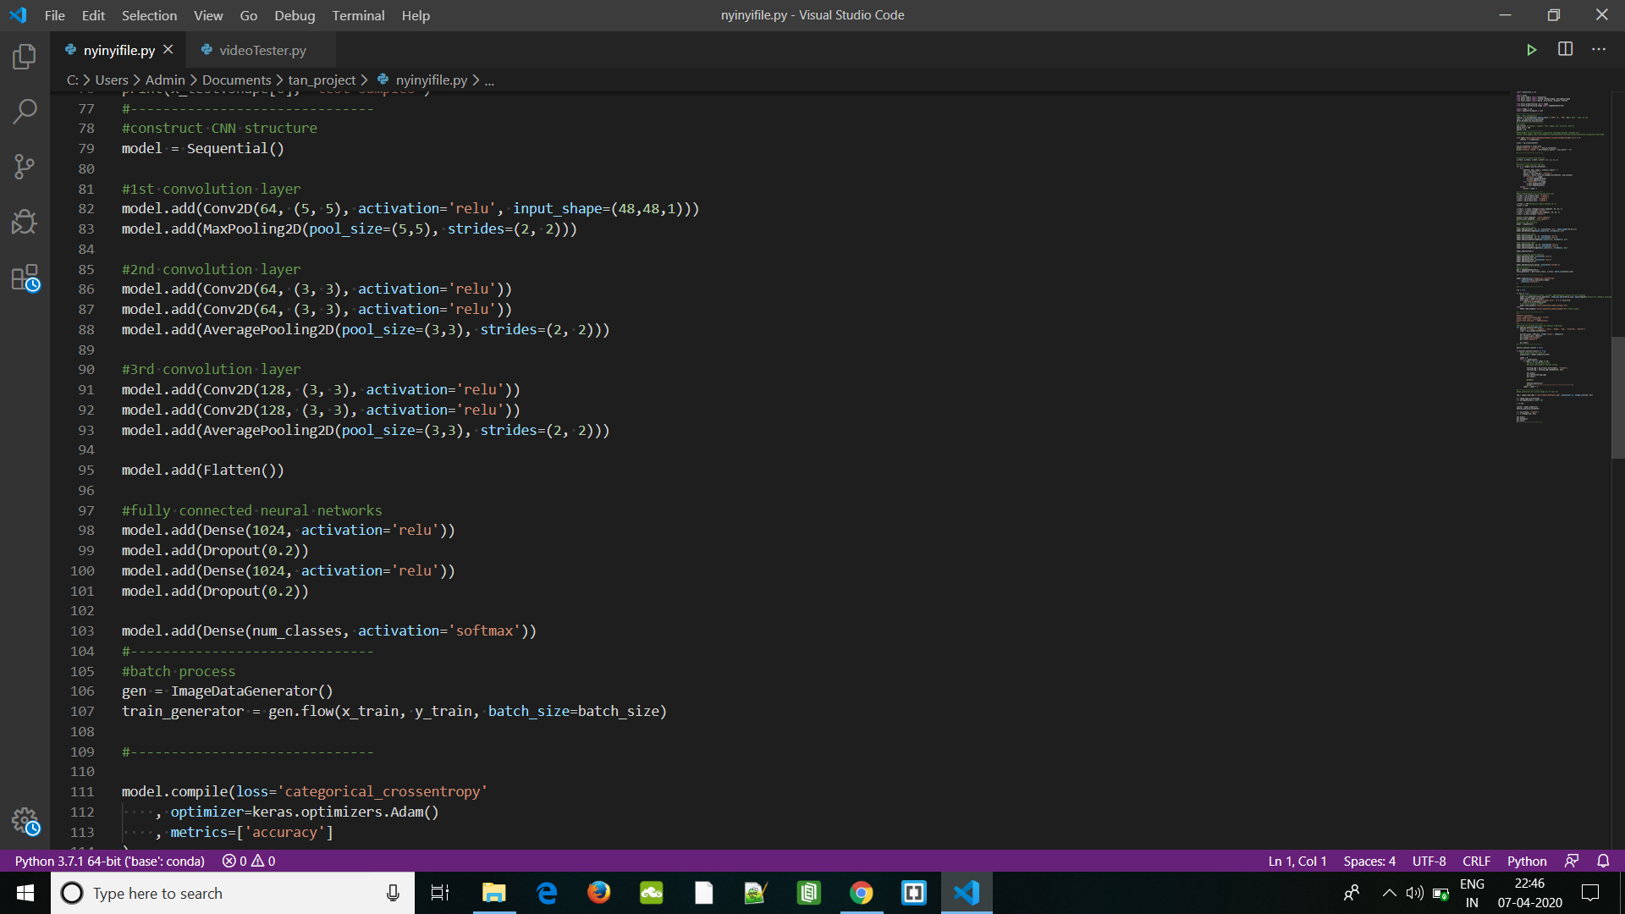

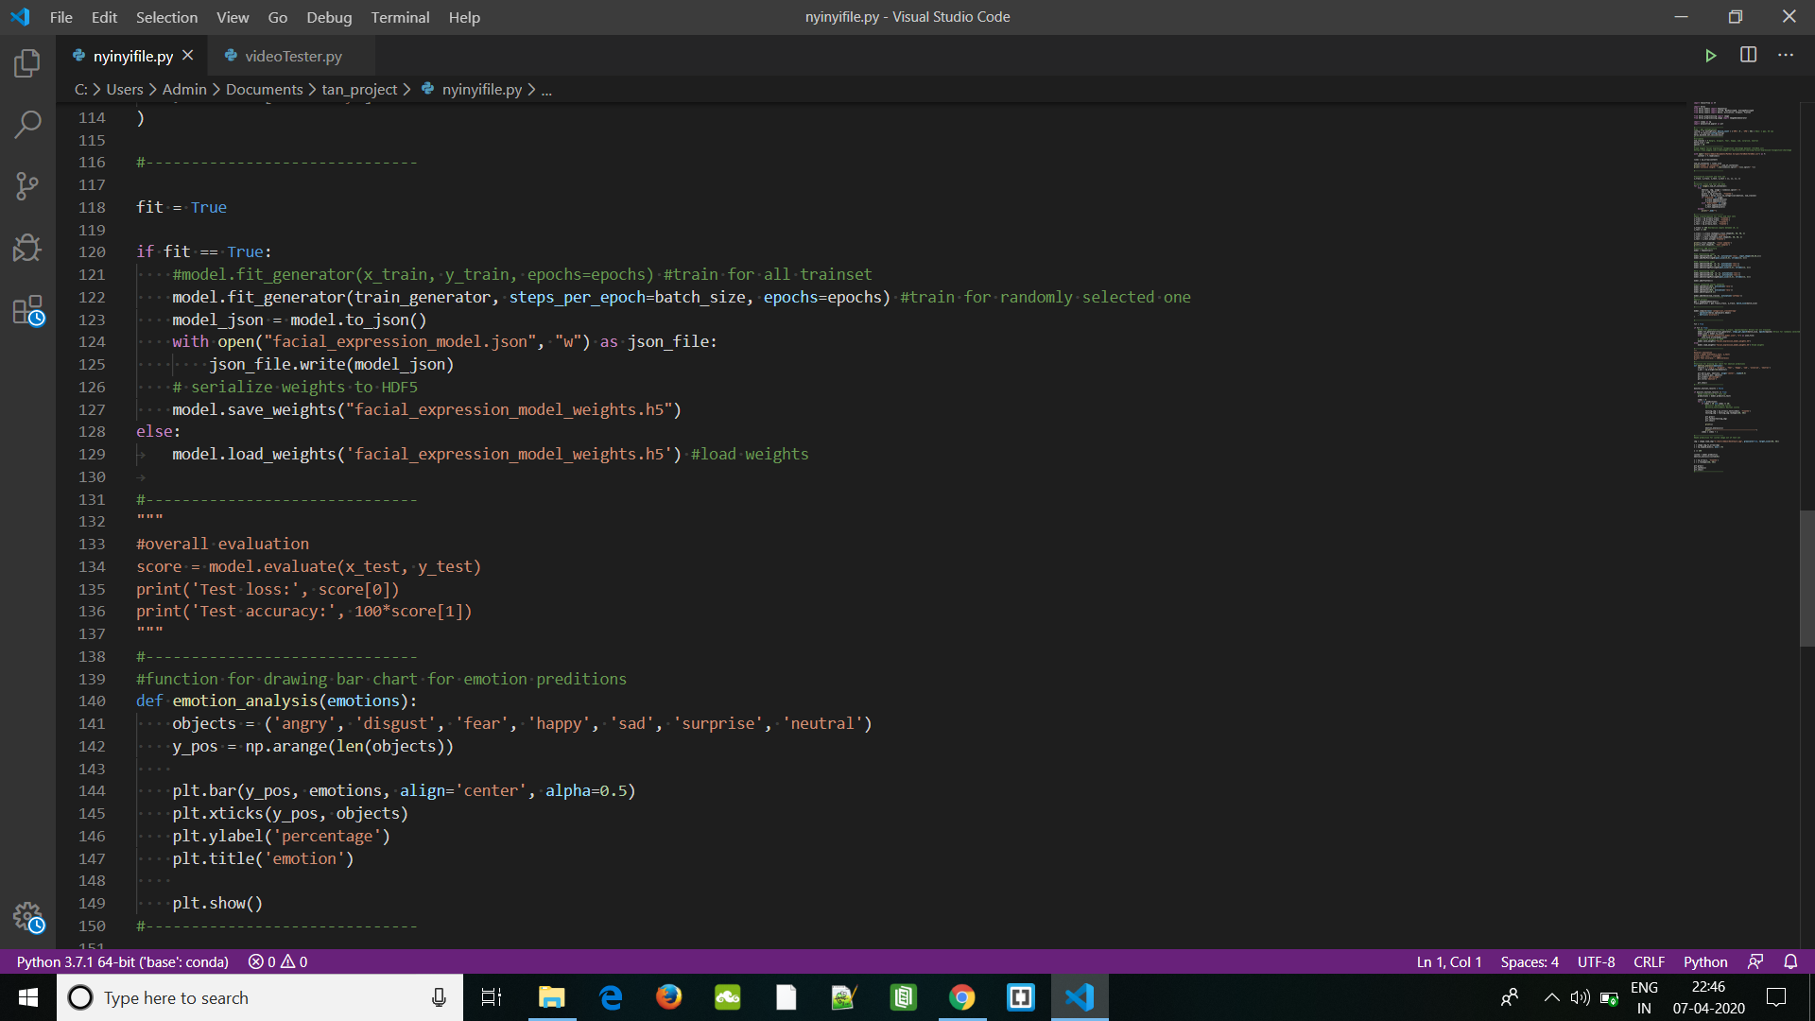

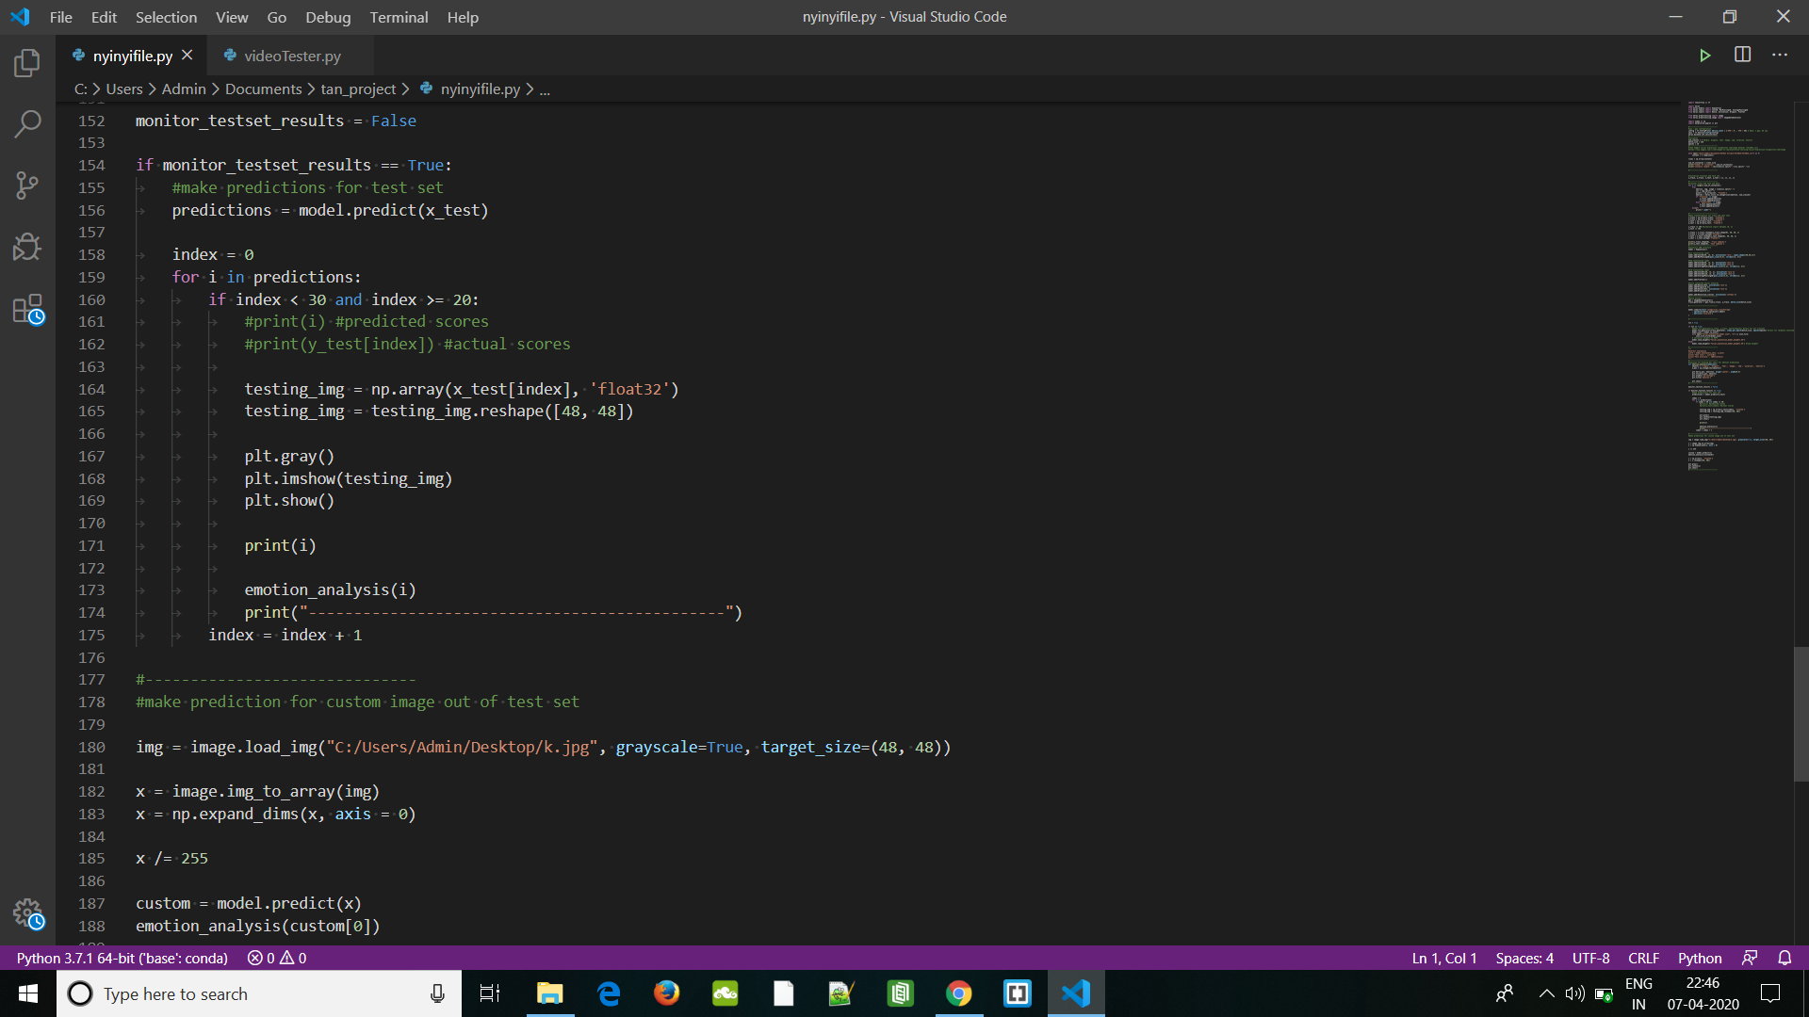

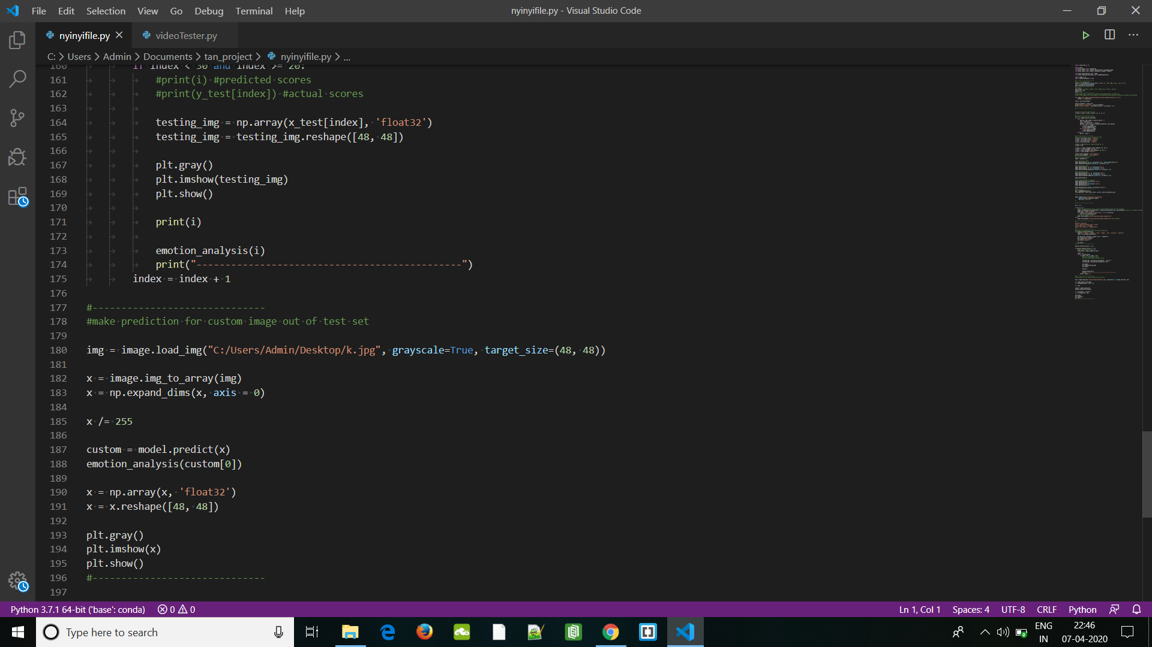

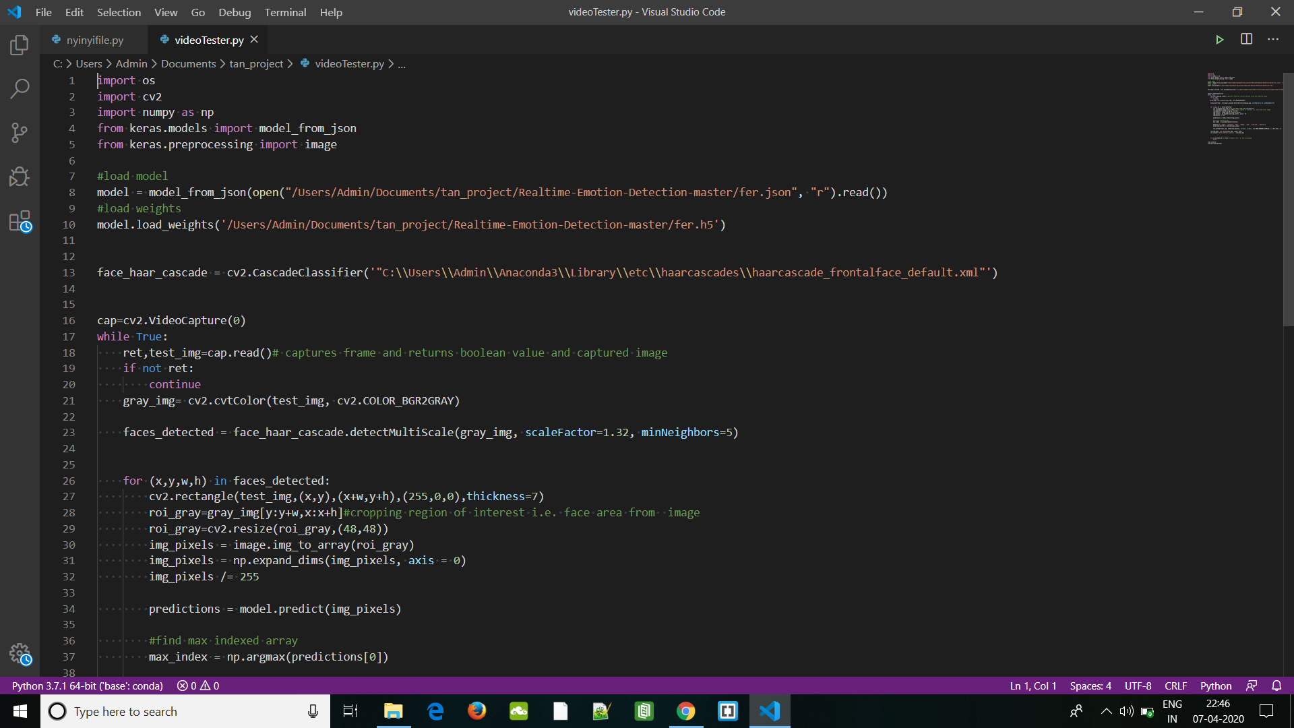

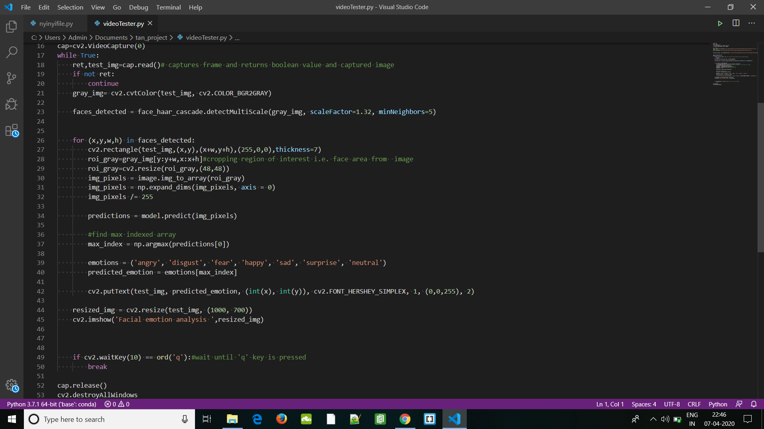

**TESTING-**

**Test Methods:**

Testing of diverse features has been performed in Facial Expression Recognition System. For each module, corresponding outputs were checked. For testing each module, the output produced from running the code was checked with the test data set.

**System Testing:**

System testing was done by giving different training and testing datasets. This test was done to evaluate whether the system was predicting accurate result or not. During the phase of the development of the system our system was tested time and again. The series of testing conducted are as follows:

**Unit Testing:**

Unit testing is a method by which individual units of source code, sets of one or more program modules together with associated control data, usage procedures, and operating procedures, are tested to determine if they are fit for use. In our tool, we considered each module as one unit and tested these units with help of test cases and test plan developed. Unit testing was carried out on each module and on every function within the module. Output of each unit was assessed for accuracy and if found incorrect, appropriate corrections were made.

|  |  |  |  |  |
| --- | --- | --- | --- | --- |
| Test case ID | Step Description | Expected Result | Actual Result | Pass/Fail |
| 1 | User captures image to be uploaded. | Image not taken Properly or Wrong image. | Recapture image. | Pass |
| 2 | User selects a image. | The selected image should be opened. | The selected document is opened. | Pass |
| 3 | User selects image of very high resolution or Noisy image. | Prompt the user to enter another image of smaller resolution. | Message displaying this is not a Human Face or this image is not proper to find an emotion. | Pass |
| 4 | User selects image of person with mixed emotions. | Best Case Scenario is taken. | Selects single Emotions which is the closest. | Pass |
| 5 | User selects image displaying correct emotion of the person. | Correct Emotion is Displayed. | Display the Emotion Box message with the correct gesture. | Pass |

In unit testing, we designed the whole system in modularized pattern and each module was tested. Till we get the accurate output from the individual module we worked on the same module.

**RESULTS AND OUTPUT-**

**Dataset trained successfully**



**Accuracy Check of the model-**



**Sample Outputs-**

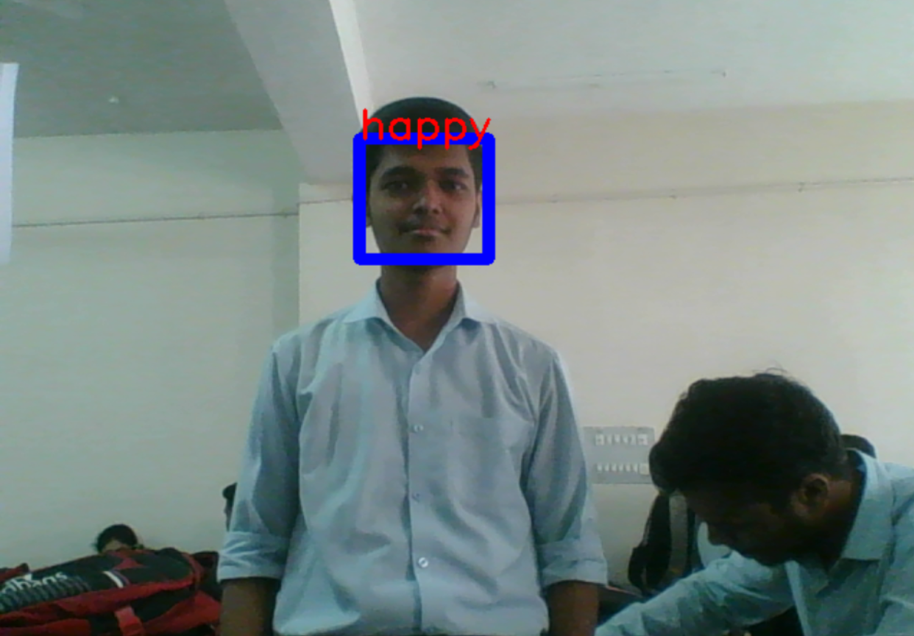

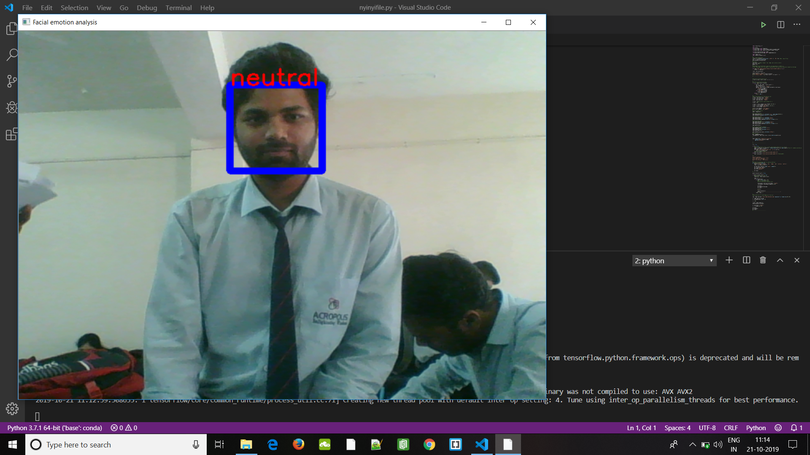

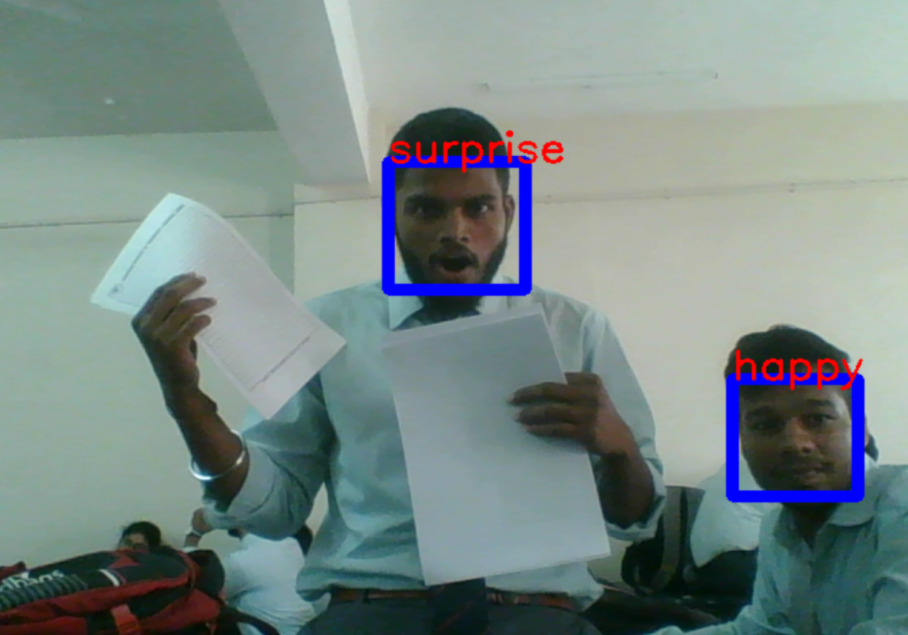

**CONCLUSION -**

In this case, when the model predicts incorrectly, the correct label is often the second

most likely emotion. The facial expression recognition system presented in this research work contributes a resilient face recognition model based on the mapping of behavioral characteristics with the physiological biometric characteristics. The physiological characteristics of the human face with relevance to various expressions such as happiness, sadness, fear, anger, surprise and disgust are associated with geometrical structures which restored as base matching template for the recognition system. The behavioral aspect of this system relates the attitude behind different expressions as property base. The property bases are alienated as exposed and hidden category in genetic algorithmic genes. The gene training set evaluates the expressional uniqueness of individual faces and provide a resilient expressional recognition model in the field of biometric security. The design of a novel asymmetric cryptosystem based on biometrics having features like hierarchical group security eliminates the use of passwords and smart cards as opposed to earlier cryptosystems. It requires a special hardware support like all other biometrics system.

This research work promises a new direction of research in the field of asymmetric biometric cryptosystems which is highly desirable in order to get rid of passwords and smart cards completely. Experimental analysis and study show that the hierarchical security structures are effective in geometric shape identification for physiological traits.

**Future Scope-**

It is important to note that there is no specific formula to build a neural network that would guarantee to work well. Different problems would require different network architecture and a lot of trail and errors to produce desirable validation accuracy. This is the reason why neural nets are often perceived as "black box algorithms.".

In this project we got an accuracy of almost 70% which is not bad at all comparing all the

previous models. But we need to improve in specific areas like-

• number and configuration of convolutional layers

• number and configuration of dense layers

• dropout percentage in dense layers

But due to lack of highly configured system we could not go deeper into dense neural

network as the system gets very slow and we will try to improve in these areas in future.

We would also like to train more databases into the system to make the model more and more accurate but again resources becomes a hindrance in the path and we also need to improve in several areas in future to resolve the errors and improve the accuracy.

Having examined techniques to cope with expression variation, in future it may be

investigated in more depth about the face classification problem and optimal fusion of color and depth information. Further study can be laid down in the direction of allele of gene matching to the geometric factors of the facial expressions. The genetic property evolution framework for facial expressional system can be studied to suit the requirement of different security models such as criminal detection, governmental confidential security breaches etc.

**REFERENCES-**

* Wikipedia- Artificial Neural Netwok & Convoluted Neural Netwok

* Omar Ayman,Emotion Analysis,github-<https://github.com/omar178/Emotion-recognition>,2016.
* Facial Emotion Detection using CNN and Representional Autoencoders Units By Prudhvi Raj Dachpally,School of Informatics and Computing,Indiana University.
* Facial Expression Recognition using a neural network by

Christine Lisetti,Florida International University.

**GUIDE REMARK**